**BIS 305**

# Assignment 2

**Due 9/19/22**

**Compute the combined checking and savings account balance for each record in the *Base Data* worksheet. Then sort the records by the number of months as a customer of the bank. From examining the data, does it appear that customers with a longer association with the bank have more assets?**

There appears to be no association between how long a customer has been with the bank and how much assists the customer has at the bank.

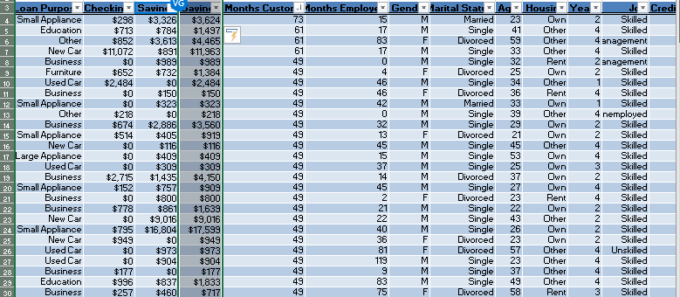

**Apply Pareto analysis to draw conclusions about the combined amount of money in checking and savings accounts.**

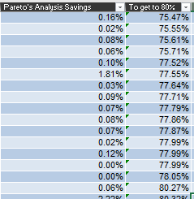

417/425 = It takes 98.11% of the savings accounts to account for 80% of all savings in this dataset.

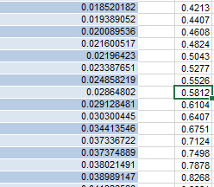

421/425 = = It takes 99.05% of the checking accounts to account for 80% of all savings in this dataset.

This tells me that out of all the money in both the savings and checkings fields, a small amount of people hold a big chunk of the total amount for both savings aand checkings sum aount.

**Use Excel’s filtering capability to extract all records for new-car loans. How many individuals with new-car loans are single, married, and divorced?**

New-car loans (single): 59

New-car loans (married): 8

New-car loans (divorced): 37

**Use Excel’s filtering capability to extract all records for individuals employed less than 12 months. Can you draw any conclusions about the credit risk associated with these individuals?**

**82/ 145 (56.55%) Of the customers that have been employed < 12 months are high credit risk**

**63/145 (43.45%) Of the customers that have been employed < 12 months are low credit risk**

**There doesn’t seem to be any association with this.**

2.Modify the data in the *Base Data* worksheet in the Excel file *Credit Risk Data* using IF functions to include new columns, classifying the checking and savings account balances as low if the balance is less than $250, medium if at least $250 but less than $2000, and high otherwise.

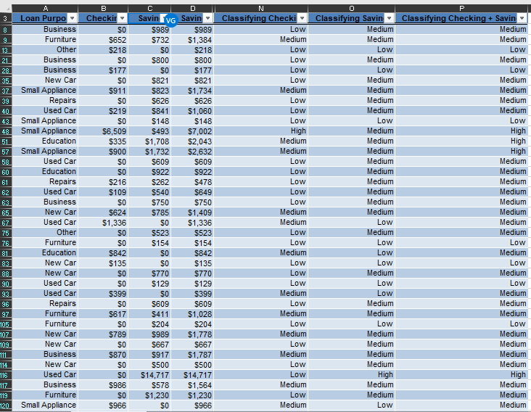

How many accounts are low? Medium? And High?

High Checking = 9, Low Checking = 100, Medium Checking = 36

High Savings = 20, Low Savings = 35, Medium Savings = 90

High Savings + checking’s = 30

Low Savings + checking’s = 18

Medium Savings + checking’s = 97

**Use PivotTables to find the number of loans by different purposes, marital status, and credit risk in the Excel file *Credit Risk Data (Base Data* worksheet*).***

|  |  |
| --- | --- |
|  |  |
| ALL TOGETHER |  |
| **Row Labels** | **Count of Loan Purpose** |
| **Business** | **44** |
| **Divorced** | **14** |
| High | 12 |
| Low | 2 |
| **Married** | **4** |
| High | 1 |
| Low | 3 |
| **Single** | **26** |
| High | 10 |
| Low | 16 |
| **Education** | **23** |
| **Divorced** | **13** |
| High | 8 |
| Low | 5 |
| **Married** | **1** |
| Low | 1 |
| **Single** | **9** |
| High | 6 |
| Low | 3 |
| **Furniture** | **85** |
| **Divorced** | **44** |
| High | 24 |
| Low | 20 |
| **Married** | **5** |
| High | 2 |
| Low | 3 |
| **Single** | **36** |
| High | 17 |
| Low | 19 |
| **Large Appliance** | **4** |
| **Divorced** | **1** |
| High | 1 |
| **Married** | **1** |
| High | 1 |
| **Single** | **2** |
| High | 1 |
| Low | 1 |
| **New Car** | **104** |
| **Divorced** | **37** |
| High | 25 |
| Low | 12 |
| **Married** | **8** |
| High | 4 |
| Low | 4 |
| **Single** | **59** |
| High | 36 |
| Low | 23 |
| **Other** | **6** |
| **Divorced** | **2** |
| High | 1 |
| Low | 1 |
| **Single** | **4** |
| High | 3 |
| Low | 1 |
| **Repairs** | **12** |
| **Divorced** | **6** |
| High | 3 |
| Low | 3 |
| **Married** | **1** |
| Low | 1 |
| **Single** | **5** |
| High | 1 |
| Low | 4 |
| **Retraining** | **2** |
| **Married** | **1** |
| High | 1 |
| **Single** | **1** |
| Low | 1 |
| **Small Appliance** | **105** |
| **Divorced** | **32** |
| High | 14 |
| Low | 18 |
| **Married** | **13** |
| High | 7 |
| Low | 6 |
| **Single** | **60** |
| High | 21 |
| Low | 39 |
| **Used Car** | **40** |
| **Divorced** | **7** |
| High | 3 |
| Low | 4 |
| **Married** | **2** |
| High | 1 |
| Low | 1 |
| **Single** | **31** |
| High | 8 |
| Low | 23 |
| **Grand Total** | **425** |

LOAN PURPOSE

|  |  |
| --- | --- |
| **Row Labels** | **Count of Loan Purpose** |
| Business | 44 |
| Education | 23 |
| Furniture | 85 |
| Large Appliance | 4 |
| New Car | 104 |
| Other | 6 |
| Repairs | 12 |
| Retraining | 2 |
| Small Appliance | 105 |
| Used Car | 40 |
| **Grand Total** | **425** |

Marital Statues

|  |  |
| --- | --- |
| **Row Labels** | **Count of Marital Status** |
| Divorced | 156 |
| Married | 36 |
| Single | 233 |
| **Grand Total** | **425** |

CREDIT RISK

|  |  |
| --- | --- |
| **Row Labels** | **Count of Credit Risk** |
| High | 211 |
| Low | 214 |
| **Grand Total** | **425** |